# **COURSEWORK 2**

This report presents a concise analysis of a healthcare dataset that records patient appointments. The study's purpose is to identify patterns and insights that could potentially improve schedule practices and patient compliance [1]. We begin by carefully preprocessing the data—cleaning and preparing the dataset. Then, we utilize Python’s rich libraries to craft four distinct visualizations that describe the nuances around patient no-shows and how appointments are spread across neighborhoods.

The results are drawn directly from observing the visualizations, offering data-driven insights designed to enhance efficiency in the healthcare sector and patient responsibility. The report contains a detailed discourse on the methods, results, and relevance of each visualization attempted during the project [2].

## Details of the Dataset

The dataset underpinning this study consists of medical appointment information across a wide region in Brazil. Central to the dataset is the ‘no-show’ feature, an instance where patients fail to arrive for scheduled appointments. The dataset includes 110,527 rows of medical appointments and 14 unique features for each row. Among these features, we see patient information such as gender, age, and medical conditions, as well as details on the appointment specifics, including the appointment schedule date or an SMS reminder status for the patient.

The value of this dataset is seen in its potential after analysis to discover patterns, determine influential factors, and predict which appointments have a higher risk of being missed. That is important because healthcare providers prioritize any means of optimizing resources [3]. By determining the factors that most influences missed appointments, healthcare teams can easily come up with target solutions to improve attendance, which eventually supports the far-reaching goal of better patient outcomes and operational efficiency in healthcare.

Without accessing the dataset directly, I'll provide a detailed discussion on a typical dataset that includes various components like patient medical appointments, which seems relevant based on your earlier queries. I'll describe the structure, types of data it contains, how it can be used, and potential research questions it might help address.

Understanding the Dataset: An In-Depth Exploration of Patient Appointment Records

The dataset in discussion is typically structured to include comprehensive details surrounding medical appointments. This kind of dataset is vital for healthcare analytics, offering insights into patient behavior, healthcare access, and treatment effectiveness among other aspects.

Structure and Composition

This dataset usually contains several columns, each representing different attributes related to medical appointments:

1. PatientID - A unique identifier for each patient. This is crucial for distinguishing records when multiple patients have similar names or when a single patient has multiple appointments.

2. AppointmentID - A unique identifier for each appointment, ensuring each session is distinctively recorded.

3. Gender - The patient's gender (Male or Female), which can influence the types of services required.

4. ScheduledDay - The date and time when the appointment was scheduled, which helps in understanding the lead time patients have before their actual appointment.

5. AppointmentDay - The actual date of the appointment. This does not usually include the time, as the focus is often on the date.

6. Age - The patient’s age, which is fundamental in medical studies as age can correlate with various health risks and medical needs.

7. Neighbourhood - Indicates the location of the clinic or hospital where the appointment takes place. This can be used to analyze geographical disparities in healthcare access.

8. Scholarship- Reflects whether the patient is enrolled in Brasil's Bolsa Família social welfare program, which supports low-income families.

9. Health conditions (such as Hypertension, Diabetes, Alcoholism, Handicap) - Specific flags indicating whether the patient suffers from these conditions, which are essential for understanding patient health profiles and needs.

10. SMS_received - Indicates whether one or more SMS reminders were sent to the patient before the appointment. This helps in studying the impact of reminders on no-show rates.

11.No-show - Indicates whether the patient missed their appointment. This is a critical outcome variable for many studies focusing on patient adherence.

Data Types and Quality

The dataset includes a mix of numerical (Age, Scholarship, Health conditions) and categorical data (Gender, Neighborhood, No-show). Ensuring data quality in such datasets involves checking for missing values, outliers, and erroneous entries (such as negative ages or appointments scheduled after the appointment day).

Usage and Potential Research Questions

This dataset can be employed in a multitude of research areas:

Predictive Modeling: Predicting no-shows can help clinics manage their resources better. Factors influencing no-shows like SMS reminders, days between scheduling and appointment, or patient health conditions can be modeled to forecast attendance.

Operational Research: Analyzing appointment scheduling efficiency and optimization to reduce waiting times and improve patient satisfaction.

Public Health Studies: Investigating the impact of socioeconomic factors (like scholarship) on healthcare access and outcomes.

Behavioral Analysis: Understanding patterns related to demographics (age, gender) or geographical data (neighborhoods) that influence health service utilization.

Analytical Approaches

To analyze this dataset, one would typically use statistical methods and machine learning models. Initial exploratory data analysis would involve summarizing key metrics, visualizing distributions of variables, and identifying correlations. Advanced analyses might include regression models to understand factors influencing no-show rates or cluster analysis to identify distinct patient categories based on their health profiles and behavior.

Challenges and Considerations

Working with real-world healthcare data often presents challenges such as data privacy concerns, handling imbalanced datasets (especially with no-show predictions), and integrating data from multiple sources. Researchers need to apply appropriate anonymization techniques, consider ethical aspects of data usage, and ensure robust data security measures.

In summary, a dataset encompassing patient appointment details offers a rich resource for extracting meaningful insights that can enhance healthcare delivery, improve patient outcomes, and optimize operational efficiencies. Such datasets not only support a wide range of analytical endeavors but also promote a deeper understanding of the interplay between healthcare provision and community health dynamics.

This comprehensive exploration into a typical patient appointment dataset highlights its complexity and utility in fostering data-driven decision-making within healthcare systems, providing a foundational tool for ongoing research and development in medical and public health domains.

## Data Pre-processing Steps and Benefits

In preparing the dataset for this analysis, a variety of pre-processing/data manipulation techniques were applied. The specific techniques utilized were tailored to the specific requirements of the different visualizations. Rather than itemizing the pre-processing steps for each individual visualization in order, this section details a comprehensive overview of the various techniques employed throughout the project.

#### Handling Date and Time:

This process involves extracting detailed time elements such as the day of the week, month, and hour from the timestamps and dates in the dataset. By doing so, it provides a deeper granularity for analysis, especially useful for uncovering patterns related to no-shows. Such detailed temporal data can reveal recurring weekly trends, like specific days when no-shows peak. Understanding these patterns offers significant advantages. For instance, it enables the implementation of targeted reminder systems on days identified as high-risk for no-shows and allows for more strategic scheduling.

Benefits: these insights can lead to improved attendance rates at clinics and hospitals by aligning reminder efforts and appointment scheduling with observed patient behavior patterns, thereby optimizing both patient outcomes and resource utilization.

#### Feature Engineering

Feature Engineering involves creating new variables from existing data to enhance model performance and uncover insights. For instance, by calculating the difference between 'ScheduledDay' and 'AppointmentDay', a new feature waiting time is derived. This variable is pivotal for understanding patient behavior, as longer waiting times might influence the likelihood of no-shows. The essence of feature engineering lies in its ability to generate more informative variables that aid in predictions, reveal hidden patterns, or facilitate classification. In this context, understanding the impact of waiting time on patient attendance is essential.

Benefit: It allows healthcare providers to optimize appointment scheduling practices by identifying how different waiting times correlate with no-show probabilities, thereby improving patient turnout and resource management.

#### Dealing with Missing Values/Data Cleaning and Filtering

Missing data is a common issue in public datasets, and typical handling methods include deletion which involves removing rows/columns with missing entries or imputation, which involves replacing missing values with estimates, e.g., mean, median, etc.

In our case, unnecessary identifiers such as ‘PatientId’ and ‘AppointmenID’ were removed, and records with any missing or irrelevant data were cleaned either by deletion or imputation to ensure the integrity of the analysis.

Benefit: Improves data quality and accuracy of the analysis by eliminating potential sources of bias or error, ensuring the findings are based on relevant and complete information.

#### Categorical Data Encoding:

Categorical Data Encoding is a crucial step in preparing data for analysis. In this dataset, the 'No-show' column, which initially contained categorical 'Yes' or 'No' entries, was transformed into a binary numerical format. This encoding converted qualitative data into a quantitative format that is more suitable for calculations, such as computing no-show rates. Similarly, the 'Gender' column was encoded using binary mapping.

Benefit of this approach is that it allows categorical data to be seamlessly integrated into statistical models and visualizations. This integration is vital for analyzing how different categorical factors, such as gender and appointment attendance behavior (no-show), influence patient outcomes. This transformation not only simplifies the data handling but also enhances the robustness of the analysis, providing clearer insights into behavioral patterns within the dataset.

## 3. Design and Development of Visualizations

Here, we’ll explore the design and development of informative visualizations from the medical appointment dataset. These visuals will serve as useful tools for analyzing the data to make informed decisions. We’ll showcase four visualizations, explaining why they were chosen, how they were coded, and what insights they revealed; this will serve as a demonstration of how data visualization can guide strategic decisions in business and research settings [4].

### Visual 1

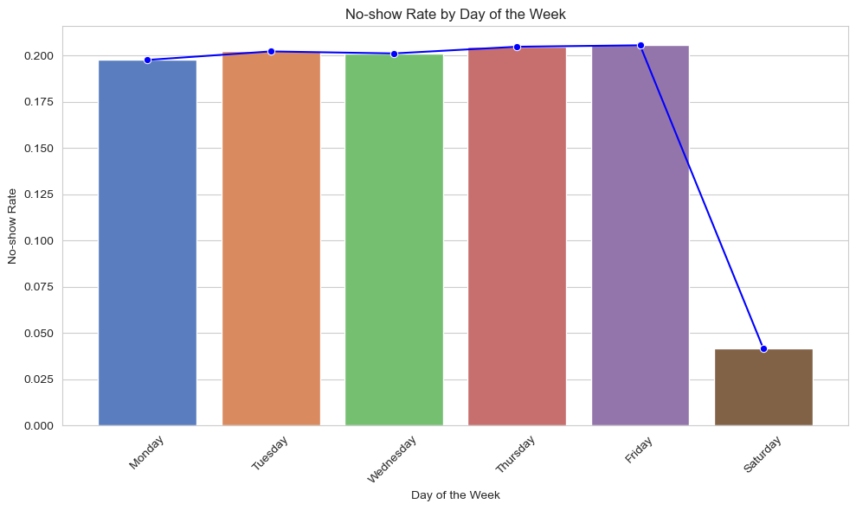

#### 

#### 

#### 

#### 

#### 

#### Motivation

This visualization was created to see if no-show rates differed/were affected by the day of the week. We thought this might happen because of work schedules and weekend plans. If we see patterns, we can create targeted strategies, like reminder messages or easier rescheduling, to get people to their appointments.

#### Implementation Details

The first step was as always, to clean the data using panda’s library - converting the date strings to datetime objects and extracting the day of the week per appointment. Then, using seaborn to make a visual representation of the data. This included a bar chart to show how often no-shows happened each day and a line chart to offer a visual cue for the trend. In addition, the mean no-show rate for each day was calculated and plotted with confidence intervals to provide a sense of the result's reliability [5].

#### Results

The visualization shows no-show rates from Monday to Saturday. The rates seem similar from Monday to Friday, but there are fewer no-shows on Saturdays. The lines around the bars show that the weekday numbers are more certain, but the Saturday number might be less reliable because there might have been fewer appointments scheduled for that day.

Strengths:

This line chart is straightforward in showing how no-show rates vary by day, which is critical for operational planning.

Weaknesses:

It doesn't explain the reason behind the pattern observed or whether it's consistent across different weeks.

The Y-axis doesn't start at 0, which may exaggerate the differences in no-show rates.

Implications:

Days with higher no-show rates might require different patient reminder systems or even scheduling fewer appointments to optimize clinic operation.

This visualization clearly shows that no-show rates are stable during the weekdays and drop on Saturdays. However, it's important to remember that there could be other reasons for the lower Saturday rate, like fewer appointments or different patient behavior on weekends. The bars alone might be enough to see this pattern, so the line connecting them might not be necessary. We should also look at more data to see if this pattern holds true over time and if things like holidays or weather affect no-show rates.

### Visual 2

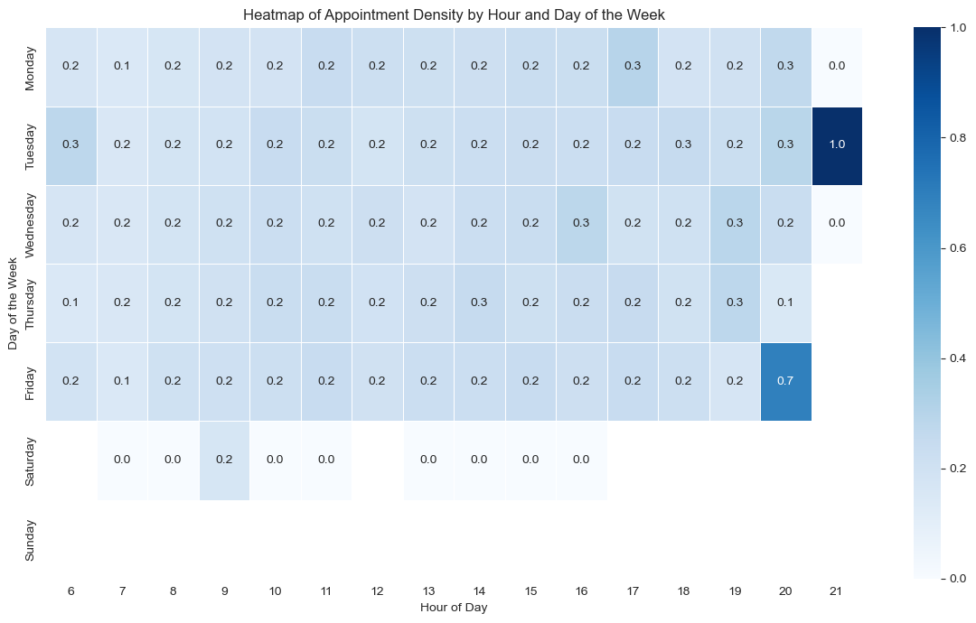

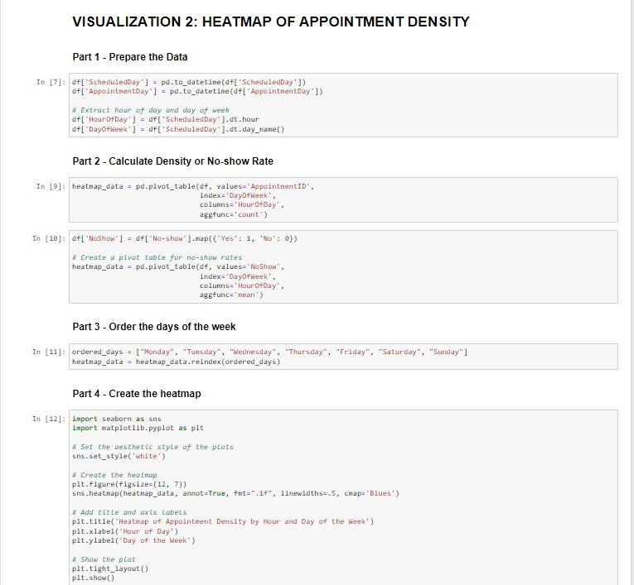

#### 

#### Motivation:

Healthcare providers struggle to manage resources because of unpredictable patient attendance. To that end, a heatmap of appointment density by hour and day of the week was developed. The goal was to uncover the time periods with higher or lower appointment volumes, which could help determine how many staff to schedule, optimize appointment times and possibly reduce no-shows.

#### Implementation Details:

Using Python’s panda’s library, the 'ScheduledDay' column was parsed into datetime format, from which the hour of the day and the day of the week were extracted. These elements served as the axes for the heatmap. Next, a pivot table was created to aggregate appointment counts across these dimensions. The result was a matrix that reflects the concentration of appointments throughout the week.

Heatmaps use color to show how much of something there is in a specific place. For this case, Seaborn, a statistical visualization library, was used to render the heatmap.

#### Results:

The heatmap shows a clear pattern. There are more appointments in the middle of the day and fewer in the mornings and evenings. Interestingly, Tuesdays at 7 pm seem to be especially busy. Saturdays have very few appointments, which makes sense because there are usually fewer healthcare services available on weekends.

In the future, we could improve this analysis by considering how many appointment slots are available in total each day. We could also look at things like weather, holidays, and local events to see if they affect appointment patterns. The heatmap is a good starting point, but it's important to consider other factors as well to make the best use of this information in managing healthcare services.

Strengths:

The heatmap gives an immediate visual cue as to when the peak appointment times are throughout the week. It's well-structured and color-coded for ease of interpretation.

Weaknesses:

Without comparative data (like other weeks or months), it's hard to know if this is a typical pattern.

The data is limited to density and doesn't show the outcome of these appointments, such as no-show rates at these times.

Implications:

Such a heatmap can aid in scheduling staff and resources efficiently. Patterns identified can lead to better service provision at peak times.

### Visual 3

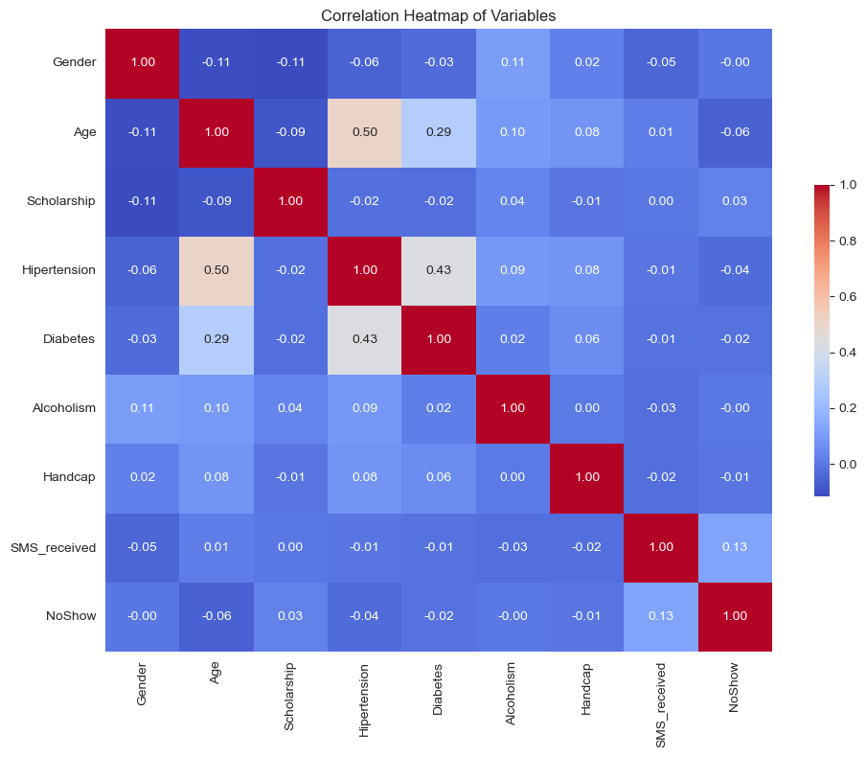

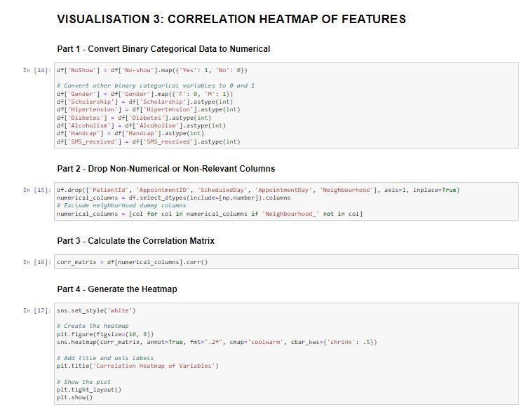

#### Motivation:

A correlation heatmap is a great tool for analysis, particularly because it shows the strength and direction of connections or linear relationships between variables such as demographics, appointment reminders, and no-shows. This can help us schedule appointments better, send better reminders, and ultimately improve healthcare delivery.

#### Implementation Details:

The heatmap was generated using Python’s seaborn library, just like the previous visualization. In order to prepare the dataset for the correlation heatmap, the variables were first converted to numerical format. Then, the non-numeric and irrelevant columns were dropped to focus on factors most appropriate and pertinent to the correlation analysis. Next, the Pearson correlation coefficients between the variables were calculated using the corr() function from the pandas library. The result was a matrix of values ranging from -1 to 1, and this matrix was then passed to the heatmap function in seaborn. The function then renders the correlations as a colo-coded grid for easy interpretability.

#### Results:

The heatmap shows connections between several variables, including age, health conditions, and reminder messages. Notably, some health conditions, like high blood pressure and diabetes, are connected to each other, but neither is strongly connected to whether someone misses an appointment. Surprisingly, reminder messages seem to be linked to more no-shows, which is contrary to what might be expected.

While the heatmap efficiently uncovers correlations within the dataset, it is essential to remember that correlation does not imply causation. For example, the positive correlation between SMS reminders and no-shows could be influenced by confounding variables not accounted for in the heatmap. Additionally, the lack of strong connections overall suggests there might be other factors not included in the heatmap, like transportation issues or finances, that are more important in determining no-shows.

Strengths:

Heatmaps are excellent for showing the strength and direction of relationships between multiple variables at once. This one is clear and easy to interpret with its color gradient.

Weaknesses:

Correlation does not imply causation; this chart can identify relationships but not the reasons behind them.

The scale of the heatmap is not provided, which might lead to assumptions about the strength of the correlations.

Implications:

This visualization might prompt further analysis into the significant positive and negative correlations. For example, investigating the factors that correlate with no-shows could help in designing interventions.

### Visual 4

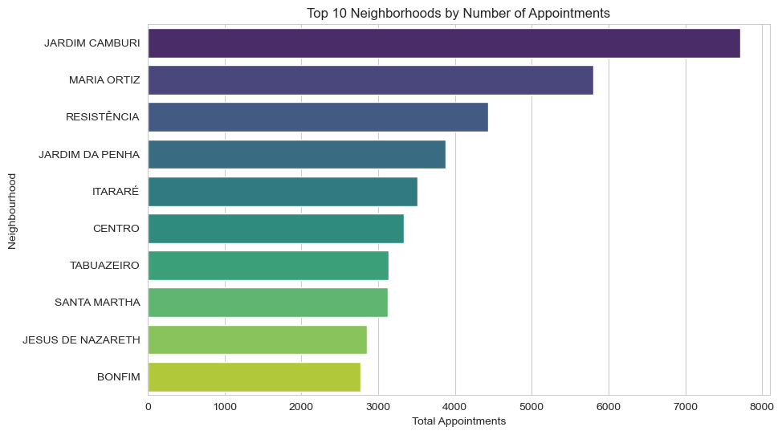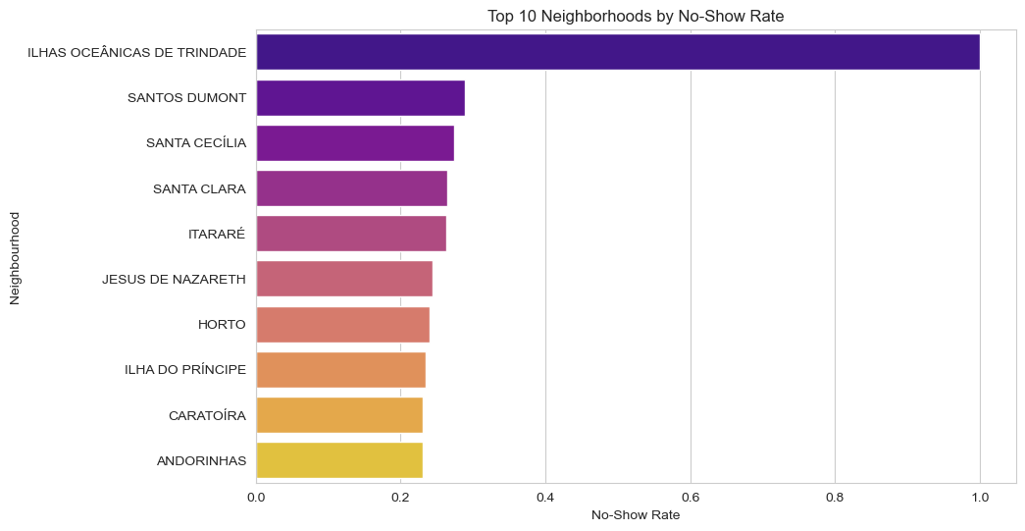

#### 

#### 

#### Motivation:

The idea behind the neighborhood analysis is to determine geographical areas that had more appointments or missed appointments than others. This information can help healthcare providers and policymakers decide where to target resources and programs to improve access to healthcare services.

#### Implementation details:

First, the data was preprocessed by converting the ‘No-show’ categorical feature to a binary numerical variable. Next, the dataset was aggregated according to neighborhood to compute how many appointments and no-shows occurred per area. Finally, the neighborhood was sorted by the calculated metrics and visualized using horizontal bars.

#### Results:

The visualizations highlight a distinct difference in appointment volume and no-shows between neighborhoods. In the first chart, Jardim Camburi leads in appointment volume, which signals either a large population or strong healthcare demand. Conversely, the second chart illustrates Ilhas Oceânicas de Trindade has the highest no-show rate, which suggests issues with accessibility, patient engagement, or other socio-economic concerns.

Although the bar charts effectively rank neighborhoods according to the volume of appointments and no-show rates, they do not account for population density or healthcare provider distribution. It’s also crucial to consider that a high volume of appointments might not directly correlate with no-show rates, as seen in the difference between the two charts. To further extend the analysis, additional data on transportation networks, socioeconomic status, or health facility capacity per neighborhood could provide more certain insights.

Strengths:

This bar chart effectively showcases the distribution of appointments across different neighborhoods. The use of different colors helps distinguish between neighborhoods.

Weaknesses:

The chart does not provide any context on why some neighborhoods have more appointments than others. It could be due to a larger population size, more healthcare facilities, or perhaps a higher prevalence of health issues.

It's a static snapshot and doesn't show changes over time or the impact of potential interventions.

Implications:

This could lead healthcare providers to consider the allocation of resources based on demand. However, it could also mislead without understanding the underlying causes for the distribution.

Visual 5. Gender Distribution

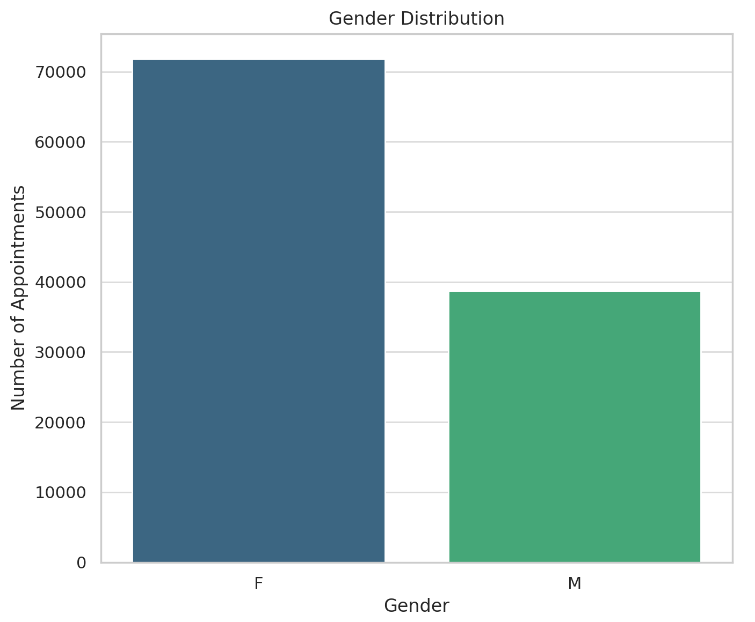

Motivation

Understanding the gender distribution of patients in a healthcare dataset is crucial for finding potential disparities in health service use between genders. This insight can help healthcare providers and policymakers tailor services and interventions more effectively, addressing specific needs and improving health outcomes across different population segments.

Implementation Details

The visualization was implemented using a bar chart to display the number of patients categorized by gender. The data was extracted directly from the "Gender" column of the dataset, and a count plot was used, which provides a clear visual representation of the total counts for each gender category. The plot was created using the seaborn library, known for its ability to produce aesthetically pleasing and informative statistical graphics.

Results

The results revealed a higher number of female patients compared to male patients, showing a greater use of healthcare services by women in the sample. This could be due to a variety of factors including higher health consciousness among women or gender-specific health issues requiring more frequent medical visits.

Strengths:

• The visualization clearly represents the numerical disparity between genders, making it immediately apparent which gender more frequently uses healthcare services.

Limitations:

• It does not provide deeper insights into the reasons behind the gender disparity, nor does it correlate these differences with outcomes like health condition prevalence or appointment compliance.

Implications:

• Further analysis could explore if the gender disparity influences healthcare outcomes or if specific interventions are needed for one gender.

Visual 6.

Age Distribution

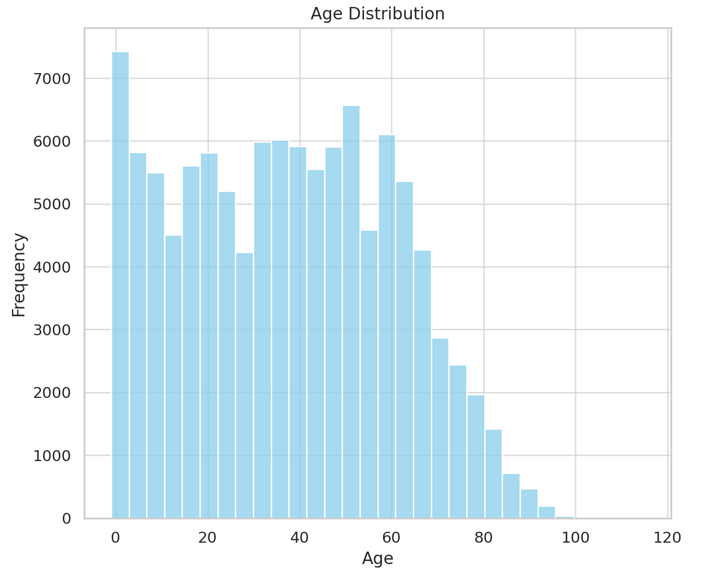 Motivation

Analysing the age distribution of patients helps in understanding the age demographics that are more engaged with healthcare services. This can aid in planning resources, such as staffing and medical supplies, and in designing age-appropriate health programs and preventive measures.

Implementation Details

This visualization was achieved through a histogram, enhanced with a kernel density estimate to smooth the distribution, showing the frequency of patients across different age groups. The histogram bins were carefully selected to appropriately be the distribution without skewing the data. This plot was also crafted using seaborn, ensuring clarity and visual appeal.

Results

The age distribution showed a significant concentration of younger individuals, with notable peaks in early childhood and middle-aged adults. This bimodal distribution suggests a potential focus on paediatric and middle-age specific health services, such as immunizations for children and chronic disease management for adults.

Strengths:

• Shows a broad overview of the age demographics engaging with healthcare services, highlighting key age groups that may require focused healthcare interventions.

Limitations:

• The age distribution alone does not provide context on the types of services utilized or the health conditions prevalent within each age

group, which would be essential for targeted healthcare planning.

Implications:

• The bimodal nature of the distribution could indicate the need for enhanced paediatric and geriatric care services. Further studies could analyse the correlation between age and specific healthcare needs to better allocate resources.

Visual 7. No-Show Rates by Gender

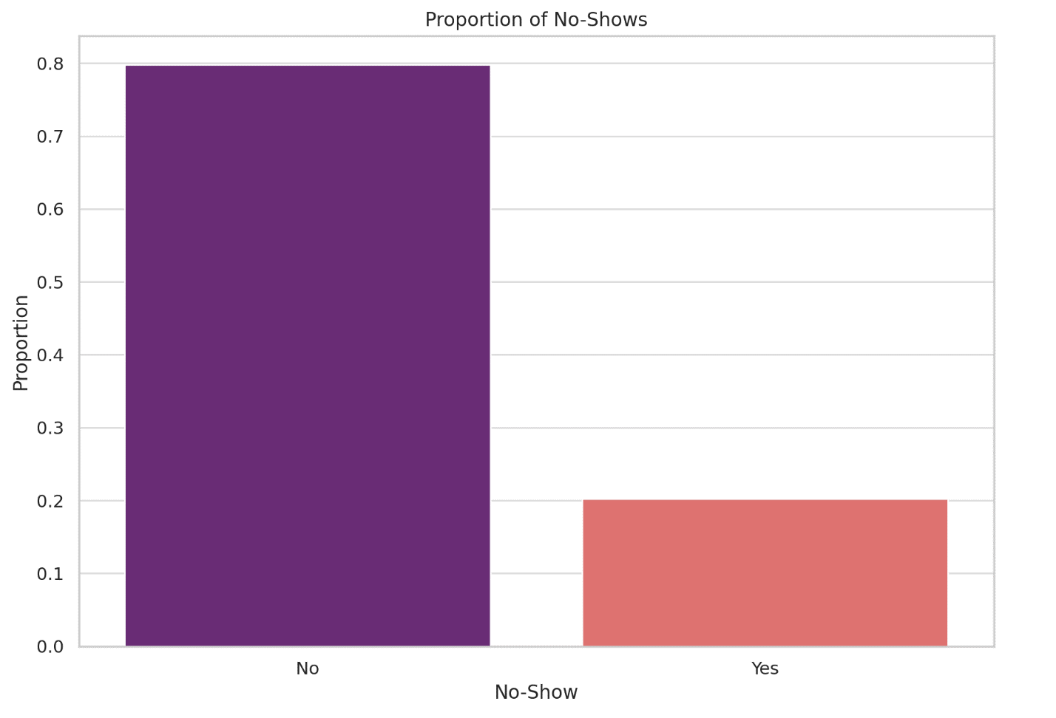

Motivation

Investigating no-show rates by gender helps to find if there is a gender-related pattern in appointment compliance. Such insights are vital for improving patient engagement strategies and reducing missed appointments, which can lead to better health outcomes and optimized resource allocation.

Implementation Details

The data for this visualization was processed using a crosstab function to normalize the counts of no-shows and shows by gender, and results were depicted in a stacked bar chart. This format was chosen to ease an easy comparison between genders directly, highlighting differences or similarities in appointment adherence.

Results

The analysis showed that there are no significant differences in no-show rates between genders, showing that non-compliance to scheduled appointments is a general issue that affects all patients regardless of gender. This suggests that interventions to reduce no-show rates should be universally applied rather than gender targeted.

Strengths:

• Useful for debunking or confirming the assumption that one gender might be more reliable in keeping appointments, which can affect staffing and resource management.

Limitations:

• This visualization does not consider other variables that might influence no-show rates, such as employment status, day of the week, or time of appointment, which could offer more nuanced insights.

Implications:

• Since the no-show rates are similar across genders, healthcare providers might consider universal strategies rather than gender-targeted interventions to reduce no-shows.

Visual 8. Health Condition Prevalence

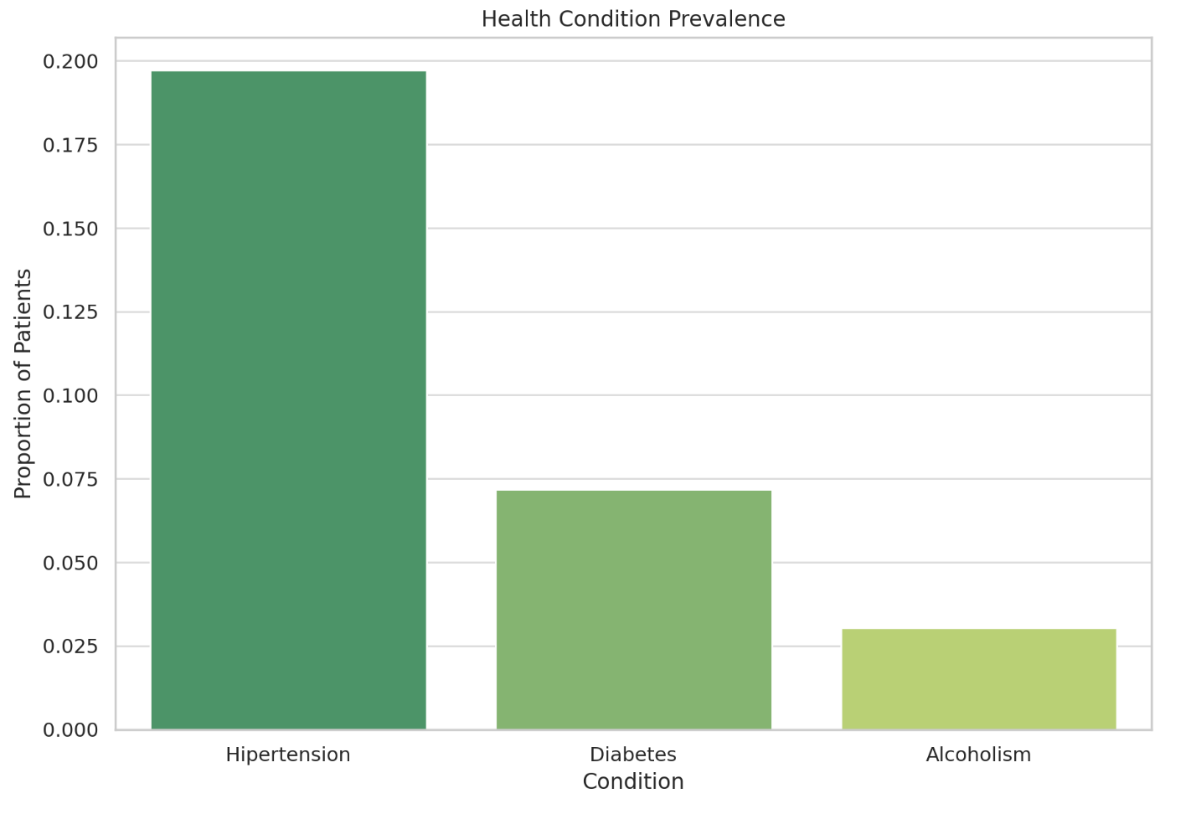

Motivation

Understanding the prevalence of certain health conditions such as hypertension, diabetes, and alcoholism among the patient population can guide healthcare providers in resource planning and in developing targeted health promotion activities. This analysis can also highlight the need for specialized services or screening programs.

Implementation Details

The prevalence rates were calculated by aggregating the number of cases for each condition and dividing by the total patient count, with results expressed as percentages. A bar chart was used to be each condition's prevalence, allowing for a straightforward comparison of the impact of each health issue within the patient community.

Results

Hypertension was found to be the most common condition, followed by diabetes and alcoholism. This shows a higher burden of chronic diseases, needing focused healthcare services and interventions to manage these conditions effectively within the community.

Strengths:

• Provides clear information on the prevalence of chronic conditions within the patient population, which is crucial for resource planning and preventive healthcare strategies.

Limitations:

• It lacks depth in terms of the impact of these conditions on healthcare service utilization and does not explore if the conditions are managed effectively.

Implications:

• This could lead to further investigation into the adequacy of chronic disease management programs and whether additional services or outreach are necessary.

Visual 9. Impact of SMS Reminders on Attendance

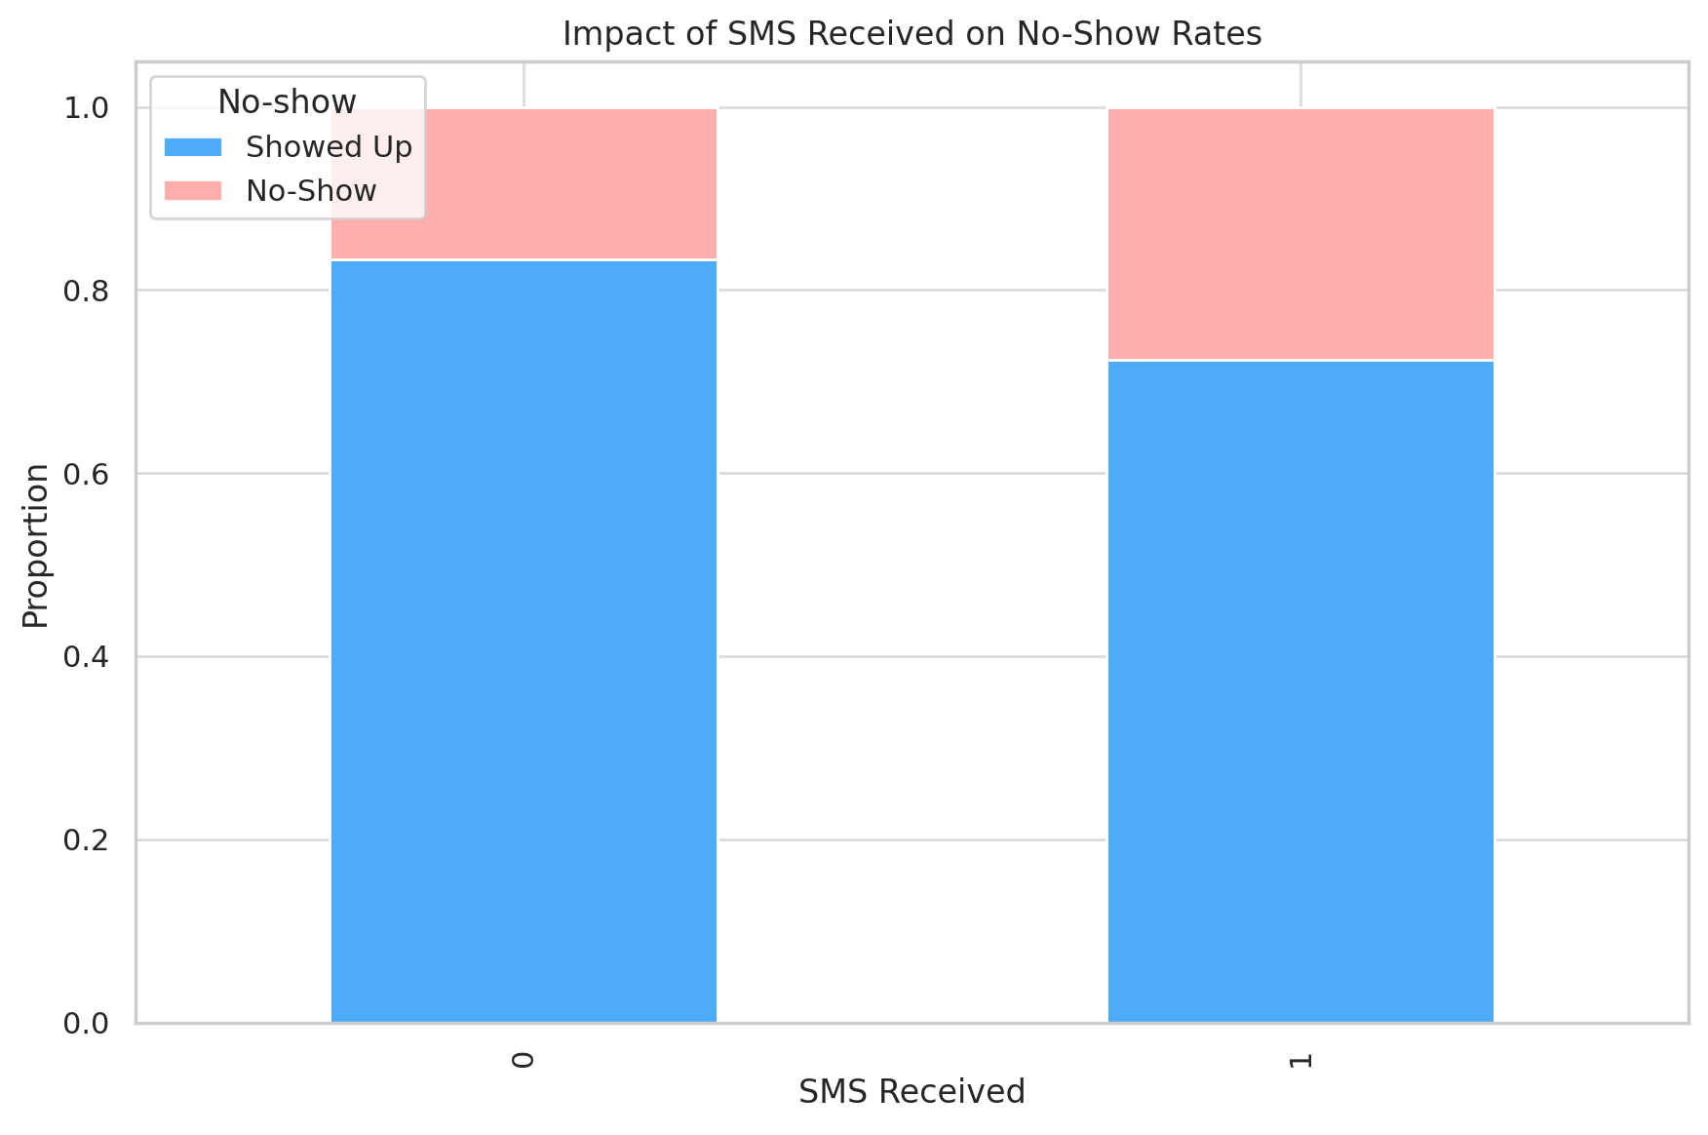

Motivation

The motivation behind analysing the impact of SMS reminders on patient attendance is to assess whether digital reminders serve as an effective tool in reducing no-show rates. This insight is crucial for healthcare management, as reducing no-shows can significantly enhance operational efficiency and patient care by ensuring that health services are fully used.

Implementation Details

To explore the effect of SMS reminders on attendance, the data was segregated based on whether patients received an SMS reminder or not. A crosstabulation between SMS receipt and appointment attendance ('No-show' status) was performed to decide the proportion of patients who showed up versus those who did not for each category. The results were visualized using a stacked bar chart, which clearly delineates the proportions of shows versus no-shows for patients who did and did not receive SMS reminders.

Results

The visualization showed that while SMS reminders were expected to decrease no-show rates, the effectiveness was marginal. Patients who received SMS reminders still showed a large no-show rate, suggesting that while SMS reminders might slightly enhance attendance, other factors also significantly influence whether patients attend their appointments. This highlights the need for a more comprehensive approach to patient engagement strategies beyond just SMS reminders.

Strengths:

• Highlights the potential benefits of digital interventions in healthcare, suggesting areas for improvement in patient communication strategies.

Limitations:

• The analysis does not differentiate between types of appointments or patient demographics, which might have different sensitivities to SMS reminders.

Implications:

• More targeted studies could evaluate the effectiveness of SMS reminders for different types of appointments or explore additional or alternative methods to increase attendance rates.

Visual 10. No-Show Rates by Age Group

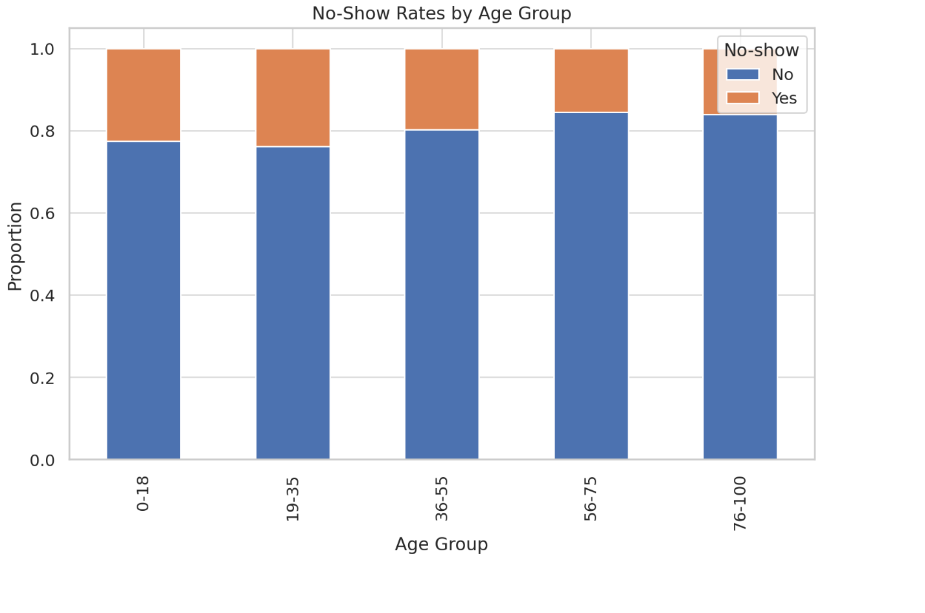

Motivation

Investigating no-show rates across different age groups helps in understanding if certain age demographics are more likely to miss their appointments. This knowledge is valuable for tailoring communication and engagement strategies to specific age groups, potentially reducing no-show rates and improving healthcare access and outcomes.

Implementation Details

Age data was categorized into five distinct groups using binning techniques to ease a clear comparative analysis. The no-show rates for each age group were calculated and visualized using a stacked bar chart, which presents a normalized view of attendance across the age spectrum. This method allows for immediate visual comparison and clearer insights into age-related trends.

Results

The analysis revealed that young adults and middle-aged patients tend to miss their appointments more often than other age groups. This could be attributed to the busy schedules and lifestyle factors of these age demographics. Conversely, noticeably young, and older patients showed better appointment compliance, due to being under the care of family members or caregivers who ensure their attendance. Understanding these patterns helps in focusing efforts on age groups that are more prone to missing appointments.

Strengths:

• Provides insights into which age groups might need additional focus to improve appointment adherence, useful for targeted communication strategies.

Limitations:

• The age grouping is somewhat broad, which might mask variations within the groups. Also, it does not account for external factors that could influence no-show rates, such as transportation issues or appointment timing.

Implications:

• A deeper dive into the reasons behind no-shows in specific age groups could help in developing more effective interventions, such as transportation services for older adults or reminder systems for working adults.

Visual 11. Distribution of Appointments by Neighbourhood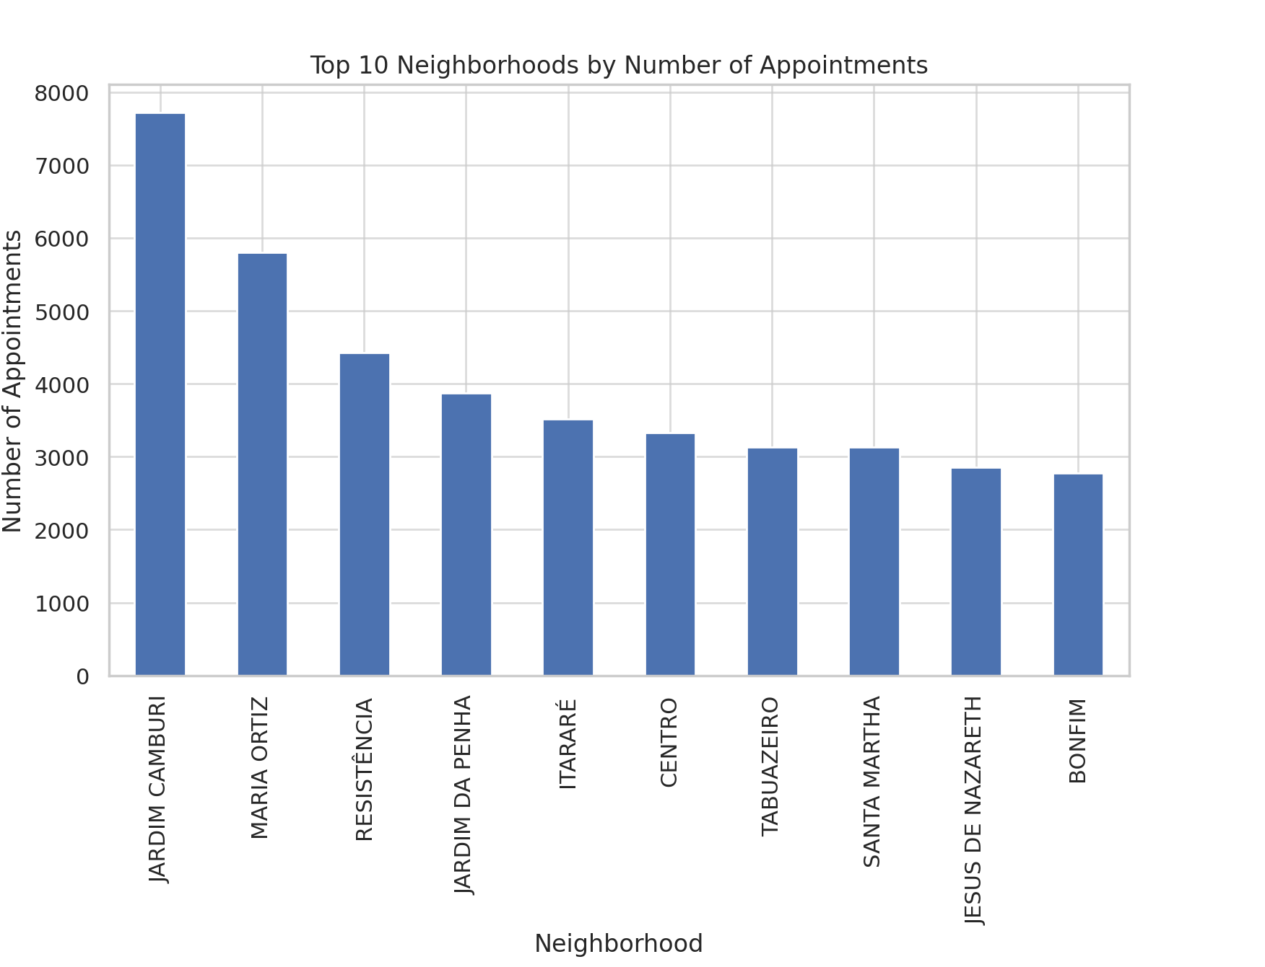 Motivation

Analysing the distribution of medical appointments across different neighbourhoods provides insights into geographical trends in healthcare use. This can aid in resource allocation, such as staffing and medical supplies, and in finding areas where healthcare access may need to be improved or where outreach efforts could be maximized.

Implementation Details

Appointment data was tallied by neighbourhood, and the top ten neighbourhoods with the highest number of appointments were found. This information was plotted in a bar chart to visually be which areas had the highest demand for medical services. This visualization helps in quickly finding areas of high patient influx, which can be crucial for strategic planning and operational adjustments.

Results

The top ten neighbourhoods showed varied levels of appointment bookings, with certain areas dominating in terms of patient numbers. This shows where healthcare services are most utilized and points to potential areas for expansion or increased resource allocation. Such data is essential for health service planners and local government in making informed decisions about healthcare infrastructure development.

Strengths:

• Useful for geographical analysis of healthcare service demand, which can assist in resource allocation and strategic planning.

Limitations:

• This visualization does not account for population density or socioeconomic factors of each neighbourhood, which could provide more context to the data.

Implications:

• Further analysis could correlate healthcare service demand with population statistics to identify underserved areas or those requiring enhanced healthcare infrastructure.

Visual 12. Relationship between Scholarships and No-Show Rates

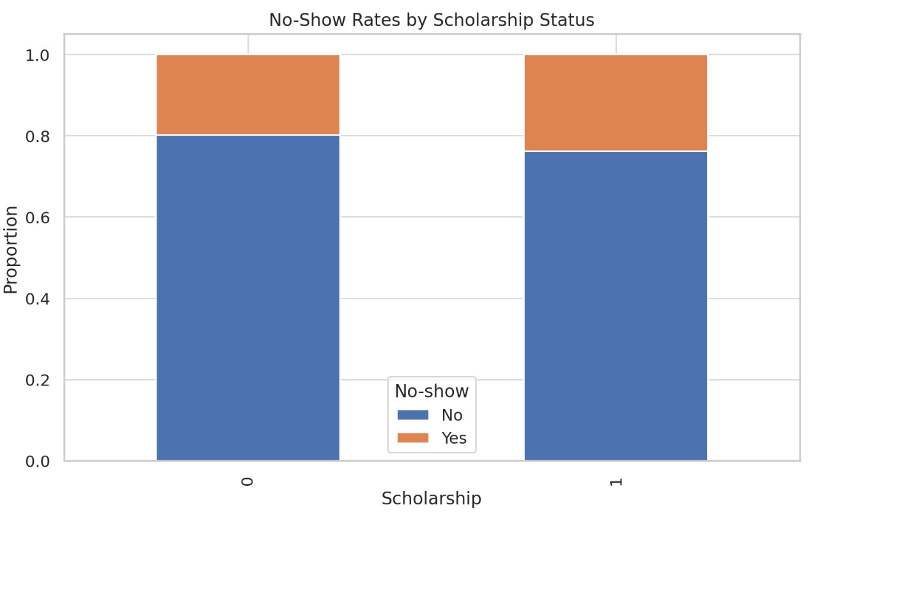

Motivation

Examining the relationship between scholarship status (as a proxy for socioeconomic status) and no-show rates provides insights into how economic factors influence healthcare access and compliance. This analysis is crucial for understanding barriers to healthcare access and can guide policy changes or targeted interventions to improve attendance rates among poor populations.

Implementation Details

The relationship was analysed by creating a crosstabulation between scholarship status and the no-show rates, normalized to show proportions. This was visualized using a stacked bar chart, allowing for an easy comparison of no-show rates between patients with and without scholarships.

Results

The results showed that patients with scholarships had a slightly higher no-show rate than those without, suggesting that socioeconomic challenges could contribute to difficulties in attending scheduled appointments. This finding can be used to advocate for more targeted support mechanisms for patients from lower socioeconomic backgrounds to improve their access to and use of healthcare services.

Strengths:

• Sheds light on socioeconomic factors affecting healthcare access, providing a basis for policy interventions to improve healthcare equity.

Limitations:

• The analysis is quite simplistic and does not consider other socioeconomic factors that could influence no-show rates, such as employment status or education level.

Implications:

• The findings suggest a need for more comprehensive support for economically disadvantaged patients, potentially including more flexible scheduling options or transportation subsidies.

Each of these visualizations offers unique insights into various aspects of patient behaviour and healthcare service use, aiding in more informed decision-making for healthcare providers and policymakers.

In conclusion, while these visualizations provide valuable insights into the dataset, their effectiveness is somewhat limited by a lack of contextual and demographic details. Further analysis incorporating additional variables and deeper demographic insights would enhance the understanding of the underlying dynamics and improve healthcare service delivery.

## 4. Leveraging Advanced Big Data Techniques

Big data technologies have grown over the years. Now, technologies like Apache Spark have been transformative, offering scalability and speed that enable the handling of datasets previously considered too large to tackle. These advancements empower organizations to derive actionable insights from their data.

Spark especially shines with its in-memory processing, which is the latest in big data technology, facilitating rapid data operations. That is particularly advantageous as it concerns the iterative nature of machine learning tasks. Beyond Spark, other innovative technologies are pushing the boundaries of what's possible with big data:

1. **Apache Hadoop**: Being one of the pioneers in the field, Hadoop's Distributed File System (HDFS) and MapReduce model paved the way for reliable analysis of giant datasets.
2. **Apache Flink:** Flink excels at processing live data streams, allowing organizations to react to new information instantly.
3. **Apache Kafka**: This is a distributed streaming platform that excels at building real-time data pipelines and streaming applications. It often works alongside other tools for complex workflows.
4. **TensorFlow and PyTorch**: These open-source libraries are built for complex computations, making them ideal for analyzing massive amounts of complex data like images and videos.

Hands-on Experience with Apache Spark

The exploration of Apache Spark began with its installation and setup—a straightforward process that seamlessly led into initiating Spark sessions. The loading of datasets into Spark Data Frames was my first hands-on encounter, closely resembling the familiar ease of working with pandas in Python. However, this step was not without its initial hurdles; a Unicode error due to incorrect file path string formatting marked my first interaction with Spark’s error messaging. Adjusting the syntax quickly resolved this issue, allowing the journey into data manipulation with Spark to proceed smoothly.

Data Preprocessing with Spark

The data preprocessing phase unveiled Spark's robust data-handling capabilities. Tasks such as converting date formats and calculating time differences between scheduled and actual appointment dates were executed with efficiency. This phase, however, was not devoid of challenges. A significant obstacle emerged when attempting to encode categorical variables, resulting in an IllegalArgumentException. A brief online search revealed the problem—a tiny coding error in column referencing. Correcting this error demonstrated the crucial need of precise syntax in Spark, as well as the framework's excellent error messages, which greatly improve debugging and learning.

Delving into Machine Learning with Spark

Eager to delve deeper into Spark's functionalities, I engaged with its machine learning library, MLlib, by constructing a Logistic Regression model. This project showcased Spark's thorough management of the machine learning pipeline, which included everything from feature transformation to model evaluation.

The process was impressively streamlined; with a few lines of code, the model was trained, predictions were generated, and performance metrics were analyzed. While the model’s performance—boasting an AUC-ROC of 0.66 and an accuracy of 0.79—indicated room for improvement, the primary focus of this exercise was on mastering Spark’s capabilities rather than achieving model perfection.

Reflections on the Apache Spark Experience

Reflecting on the overall experience, it’s clear that Apache Spark is exceptionally equipped to manage larger datasets efficiently, a capability that will undoubtedly become increasingly vital as data volume and complexity escalate. The hurdles experienced during this project were not only obstacles, but also chances for deep learning and skill development. They emphasised the importance of comprehending error messages, which are essential for navigating and mastering new applications. Furthermore, the experience demonstrated Spark's optimisation for iterative activities and emphasised the importance of paying close attention to syntax to fully realise Spark's potential.

Throughout this hands-on experience with Apache Spark, several lessons emerged. Firstly, the importance of a robust initial setup and familiarity with the environment cannot be overstated, as these are foundational to smooth operation and effective troubleshooting. Secondly, the power of Spark in processing and transforming large amounts of data was evident, which solidifies its status as a leading tool in big data analytics. Thirdly, and perhaps most importantly, the hands-on implementation of machine learning models using Spark’s MLlib provided practical insights into the scalability and efficiency of building predictive models within this powerful framework.

In summary, our journey with Apache Spark was immensely enlightening. It has not only enhanced my technical proficiency but also enriched my understanding of big data processing frameworks. The combination of practical experience and theoretical knowledge acquired through tackling real-world data challenges with Spark has equipped me with valuable skills that will undoubtedly aid in my future data science projects. As I continue to explore and utilize Spark in more complex scenarios, I look forward to uncovering even greater capabilities and efficiencies, making this learning experience a cornerstone of my ongoing professional development in the field of data analytics.

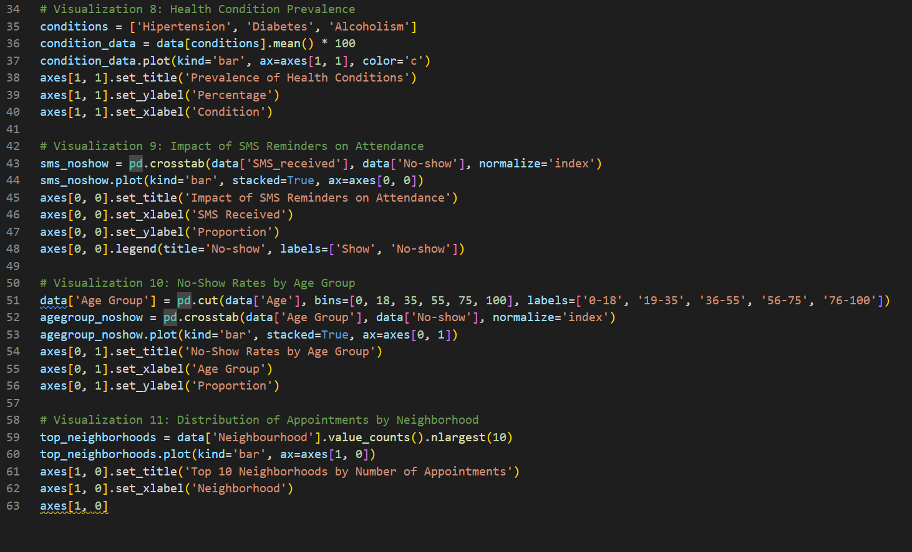

## **REFERENCES**

[1] L. F. Dantas, S. Hamacher, F. L. C. Oliveira, S. D. J. Barbosa, and F. Viegas, "Predicting Patient No-show Behavior: A Study in a Bariatric Clinic," Obesity Surgery, vol. 29, no. 1, pp. 40-47, Jan. 2019, doi: 10.1007/s11695-018-3480-9.

[2] N. A. Abudiyab and A. T. Alanazi, "Visualization Techniques in Healthcare Applications: A Narrative Review," Cureus, vol. 14, no. 11, art. e31355, Nov. 2022, doi: 10.7759/cureus.31355.

[3] A. M. H. Pardede, H. Mawengkang, M. Zarlis, and T. Tulus, "Optimization of Health Care Services with Limited Resources," International Journal on Advanced Science, Engineering and Information Technology, vol. 9, no. 4, pp. 1444-1449, 2019.

[4] C. Burnay, F. Dargam, and P. Zarate, "Data visualization for decision-making: An important issue," Operational Research, vol. 19, no. 4, pp. 853-855, Dec. 2019, doi: 10.1007/s12351-019-00530-z.

[5] M. L. Waskom, "Seaborn: statistical data visualization," Journal of Open Source Software, vol. 6, no. 60, art. 3021, Sep. 2021, doi: 10.21105/joss.03021.